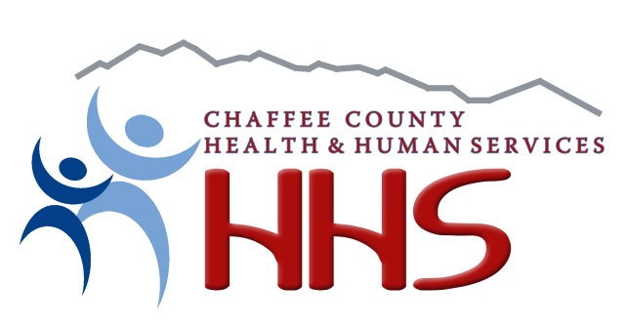

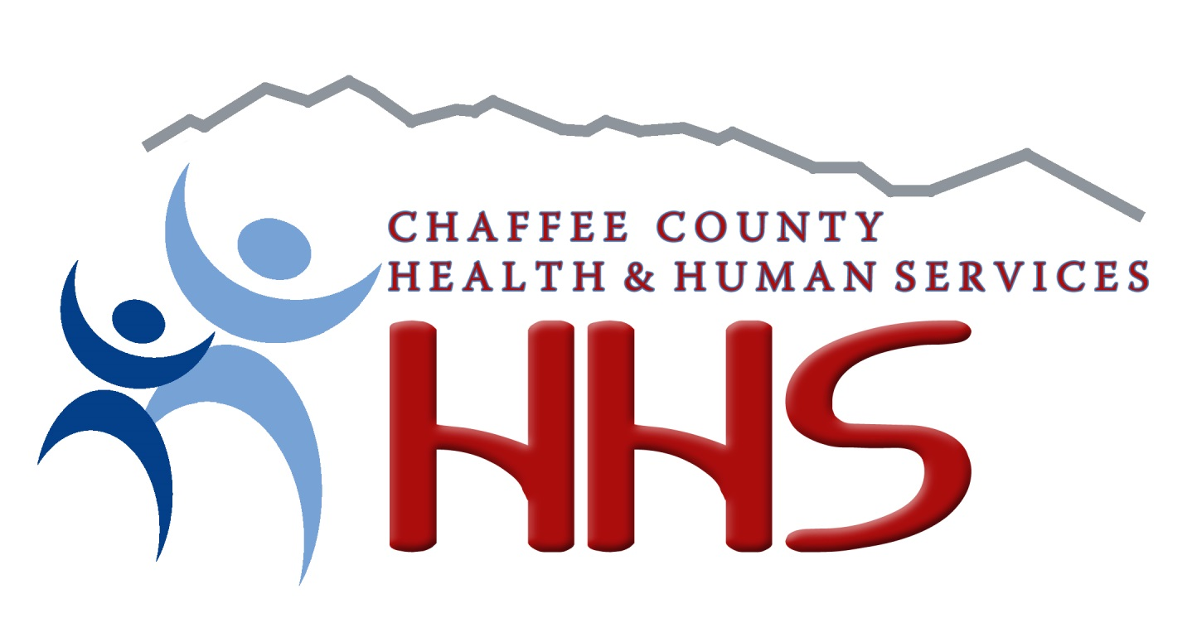

Chaffee County FYI Background Check Policy

All candidates for volunteer, paid or contract positions that work directly with children, youth or families within Chaffee County Department of Health and Human Services are subject to satisfactory background checks prior to working with these populations. Checks include a Colorado Bureau of Investigations (CBI) check, and Federal Bureau of Investigations (FBI) fingerprint check. The results of these checks are stored in locked files. Generally, candidates who have a drug/ alcohol, violence, domestic violence or other criminal charges must have eight years with no other charges before they are eligible to work for DHHS in any capacity. Candidates who pass the background checks are eligible to work at DHHS, depending on the outcome of their interview, references, and/or other qualifying processes.

In addition to the above-listed background checks, candidates who work one-on-one with children, youth and families or who transport these populations must submit a "Trails" Child Welfare check, Driver's License and a Colorado Courts check as well as submit three written references. Copies of all checks are kept in locked files which only staff have access to.

I have read, understood and agree to abide by the DHS Background

Signature: Date:

